**FLUTTER KEEP APP**

A report submitted in partial fulfilment of the requirements for the award of the degree of

**BACHELOR OF TECHNOLOGY**

in

**INFORMATION TECHNOLOGY**

By

**RAVI KUMAR GUPTA (19322)**



**SCHOOL OF COMPUTING**

**INDIAN INSTITUTE OF INFORMATION TECHNOLOGY UNA**

**HIMACHAL PRADESH**

**NOVEMBER 30, 2021**

**BONAFIDE CERTIFICATE**

This is to certify that the project titled FLUTTER KEEP APP is a bonafide record of the work done by

RAVI KUMAR GUPTA (19322)

in partial fulfilment of the requirements for the award of the degree of Bachelor of Technology in INFORMATION TECHNOLOGY of the INDIAN INSTITUTE OF INFORMATION TECHNOLOGY UNA, HIMACHAL PRADESH, during the year 2021 - 2022.

under the guidance of

Dr. Shivdutt Sharma

Project viva-voce held on: December 04, 2021

Examiner(Dr. Shivdutt Sharma )

**ORIGNALITY / NO PLAGARISM DECLARATION**

We certify that this project report is our original report and no part of it is copied from any published reports, papers, books, articles, etc. We certify that all the contents in this report are based on our personal findings and research and we have cited all the relevant sources which have been required in the preparation of this project report, whether they be books, articles, reports, lecture notes, and any other kind of document. We also certify that this report has not previously been submitted partially or as whole for the award of degree in any other university in India and/or abroad.

We hereby declare that, we are fully aware of what constitutes plagiarism and understand that if it is found at a later stage to contain any instance of plagiarism, our degrees may be cancelled.

**RAVI KUMAR GUPTA (19322)**

**ABSTRACT**

**PROJECT** **TITLE**: Google keep Notes Clone App

**PROJECT** **FOCUS**: To develop an idea of notes-taking service included as part of the free.

**INSTITUTE**: Indian Institute of Information Technology, Una

**STUDENT** **LEVEL**: Under Graduate

**ABSTRACT**:

Quickly capture what’s on your mind and get a reminder later at the right place or time.

Speak a voice memo on the go and have it automatically transcribed. Grab a photo of a poster, receipt or document and easily organize or find it later in search.

Google Keep makes it easy to capture a thought or list for yourself, and share it with friends and family.

Google Keep may be just what you need to get organized. Keep is a super simple Android app, and it can be used to store a wide variety of text or audio notes, check lists, pictures and URLs.

**ACKNOWLEDGEMENT**

We would like to thank the following people for their support and guidance without whom the completion of this project in fruition would not be possible.

We would like to express our sincere gratitude and heartfelt thanks to Dr. Shivdutt Sharma

for their unflinching support and guidance, valuable suggestions and expert advice. Their words of wisdom and expertise in subject matter were of immense help throughout the duration of this project.

We also take the opportunity to thank ourDirectorand all the faculty of School of Computing/Electronics, IIIT Una for helping us by providing necessary knowledge base and resources.

We would also like to thank our parents and friends for their constant support.

**RAVI KUMAR GUPTA (19322)**

**TABLE OF CONTENTS**

**Title Page No.**

**ABSTRACT iii**

**ACKNOWLEGEMENT iv**

**TABLE OF CONTENTS v**

**LIST OF ACRONYMS vi**

**LIST OF TABLES vii**

**LIST OF FIGURES viii**

**1 Introduction 1**

1.1 Section title 1

1.1.1 Subsection title 1

**2 Review of Literature 2**

2.1 Section title 2

2.1.1 Subsection title 2

**References 3**

**Appendices 3**

**LIST OF TABLES**

**1.1** **What** **is** **this** **project?** 1

**1.2** **Who** **can** **use** **this**? 1

**2.1 Technology** **used** 2

**2.1.1** **Timeline** 2

**2.2 Screen Shots** 3

**Introduction**

* 1. **What is this Project?**

Flutter Keep is a [note-taking](https://en.wikipedia.org/wiki/Note-taking) service included as part of the free, [web-based](https://en.wikipedia.org/wiki/Web_application) [Google Docs Editors](https://en.wikipedia.org/wiki/Google_Docs_Editors)**.**

Flutter Keep is available as a [web application](https://en.wikipedia.org/wiki/Web_application) as well as mobile app for android and ios.

The app offers a variety of tools for taking notes, including text, lists, images, and audio. Text from images can be extracted using [optical character recognition](https://en.wikipedia.org/wiki/Optical_character_recognition), and voice recordings can be transcribed.

The interface allows for a single-column view or a multi-column view. Notes can be color-coded, and labels can be applied for organization.

* 1. **Who can use this?**

As we are still in the development stage of this project not everyone can use this model directly.

Requirements for someone to use this –

1. Atleast a basic knowledge of flutter development department.
2. Basics of Github.
3. Basics of operating VS code and android studio.
   1. **Permissions Notice**

1.Camera : This is used to attach images to notes in keep.

2.Contacts : This is used to share notes to contacts.

3.Microphone : This is used to attach audio notes.

4.Location : This is used to set and fire location-based reminders.

5.Storage : This is used to add attachments from storage to their notes.

**Project Details**

**2.1 Technology used:**

* Framework used – Flutter
* Language Used—Dart
* Database—My Sql, firebase
* For UI—Google UI
* IDE used—VS code, Android Studio

|  |
| --- |
| Creating Search bar, Grid view and Login Details  (oct 15, 2021) |

**2.1.1 Timeline for creating APP:**

|  |
| --- |
| Initialisation  (sept 20, 2021) |

|  |
| --- |
| Adding pages in our project  (oct 5,2021) |

|  |
| --- |
| Creating Homepage, Particular Notes with containers  (oct 25, 2021) |

|  |
| --- |
| Edit notes, Adding New Notes  (Nov 5, 2021) |

|  |
| --- |
| SideBar, Settings page, Archive page, Making Search bar functionality  (Nov 20, 2021) |

|  |
| --- |
| Completing UI part of our app and fixing Bug.  (Nov 28, 2021) |

|  |
| --- |
| Feature remaining:  Voice search, color Notes, database work, making our app functionality, category wise notes implementation. |

**2.2 Screen Shots:-**

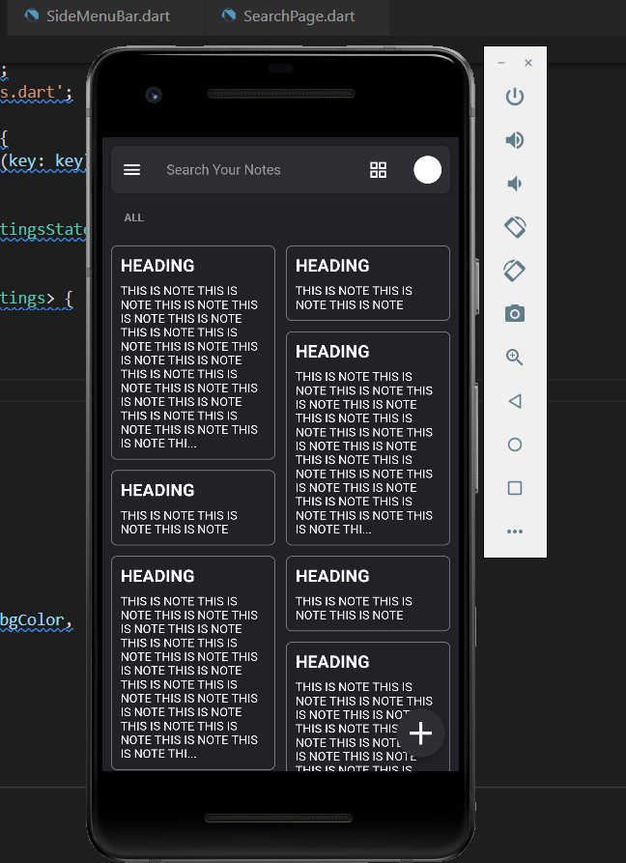 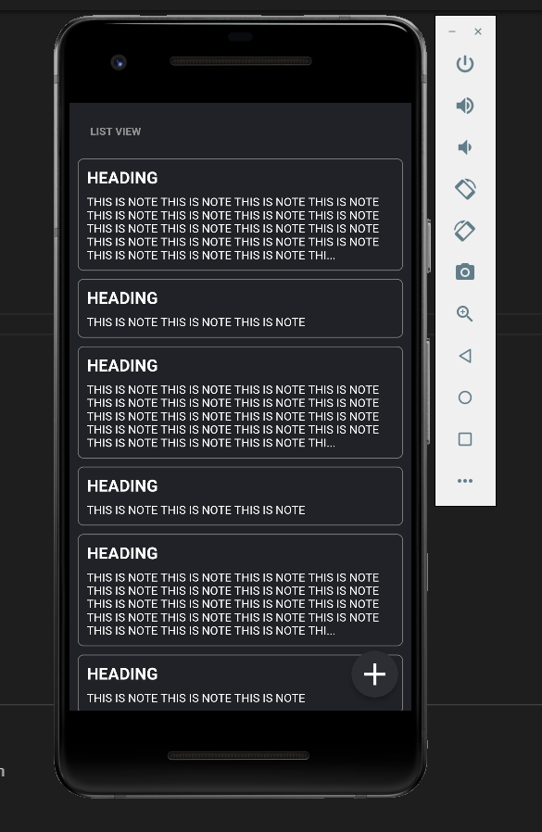

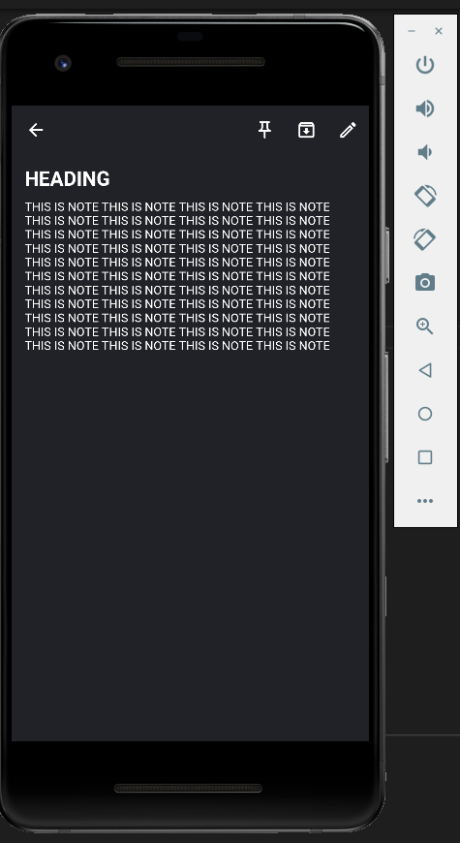 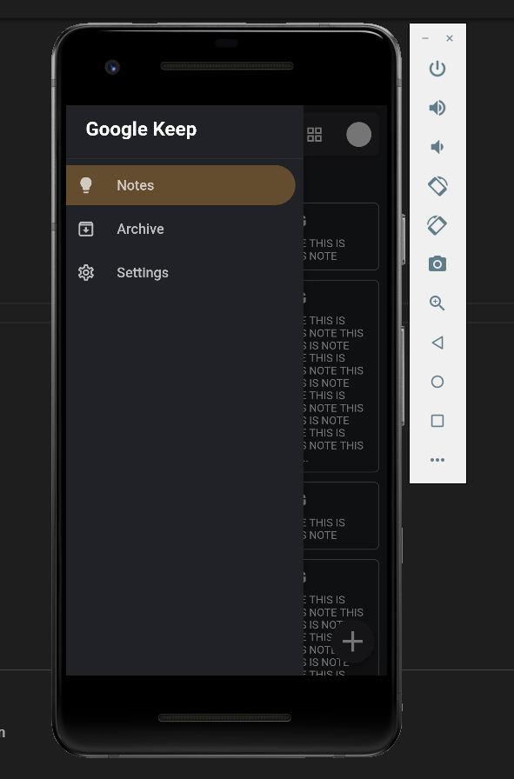

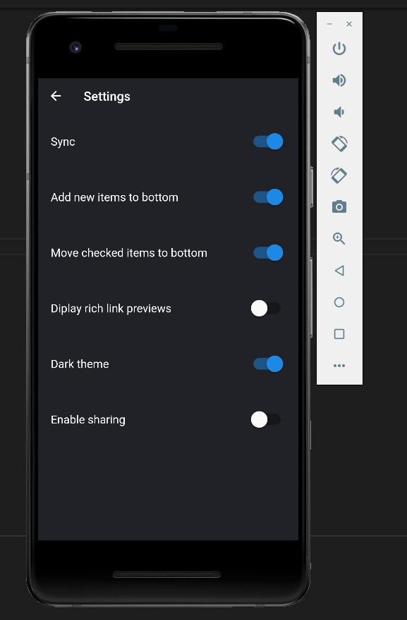 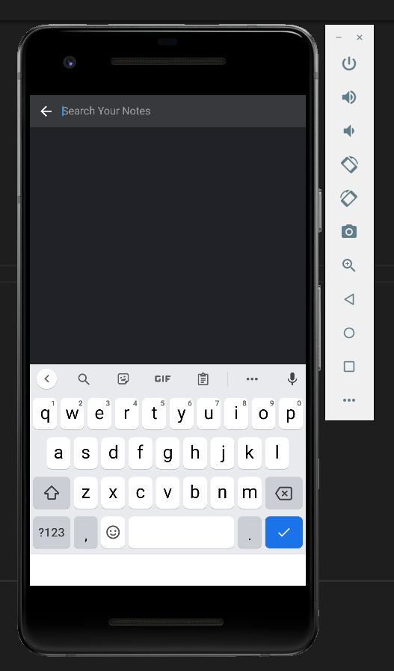

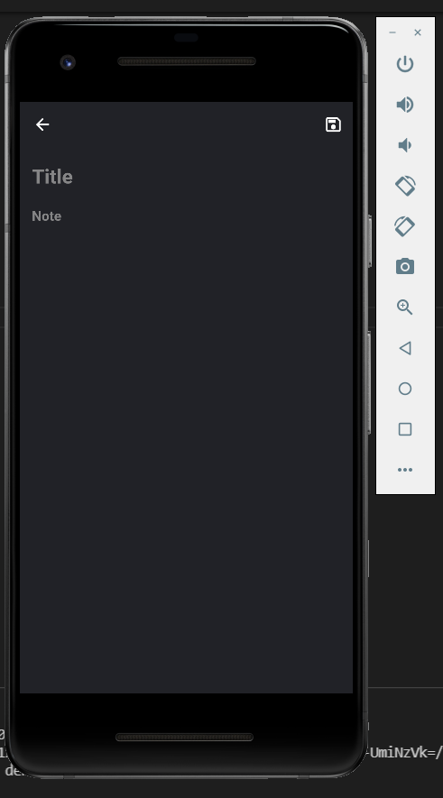

**References**

1. Udemy Cources for learning flutter, Dart, My SQL, firebase and other techincal aspects.<https://www.udemy.com/>
2. Stack Overflow for code reviewing and help. <https://stackoverflow.com/>
3. Github related posts and projects for smooth working. <https://github.com/>
4. Google UI for user interface. <https://material.io/design>
5. Google firebase docs for learning firebase. <https://firebase.google.com/docs>
6. My SQL docs for learning database work. <https://dev.mysql.com/doc/>
7. Flutter documentation for intalling most packages in our app. <https://docs.flutter.dev/>

**Appendix A**

**Code Attachments**

The complete code of the following project has been uploaded to github.

**Link:** <https://github.com/ravigupta44/flutter-keep-app>